1. **Hardware Overview**
   1. 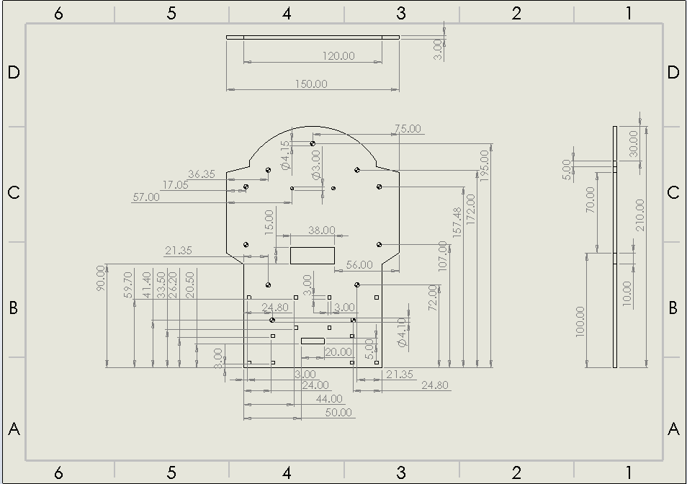**2D drawings of Chassis**

All dimensions are in mm.

Scale for bottom plate is A4 landscape 1:2.

Scale for top plate is A4 landscape 1:1.

Holes without dimensions are 4mm in diameter.

Figure 7.1 drawing of bottom plate [?]

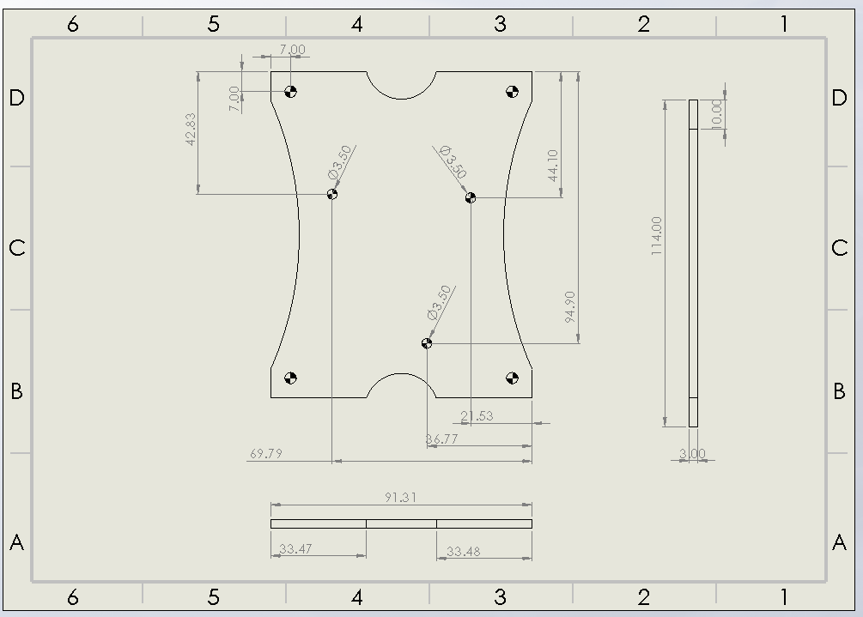

Figure 7.2 drawing of top plate [?]

* 1. **Material Choice and Ease of Manufacture**

Table 7.3 Material properties[?]

In order to choose the material that is to be used for the chassis, comparisons should be made between the properties of the materials. The table of the different materials that were researched are shown below:

|  |  |  |  |  |
| --- | --- | --- | --- | --- |
| **Material Characteristics** | **Acetal** | **Glass-Reinforced Laminate** | **Aluminium** | **Mild steel** |
| Density (Mg/m2) | 1.8 | 1.9 | 2.7 | 7.8 |
| Flexural strength (MPa) | 91 | 255 | 310 | 414 |
| Ultimate Tensile Strength (MPa) | 67 | 175 | 310 | 414 |
| Young’s Modulus (MPa) | 2.8 | 11.5 | 69 | 207 |

The three main factors to be considered for chassis material are:

**Weight:** As can be seen in the table, Acetal has the lowest density, while mild steel has the highest of all the materials. The material from which the chassis is cut must not be too dense in order to ensure that the buggy is not too heavy

**Cost:** In terms of material cost, aluminium is the most expensive and other three materials are similar in cost however cost of manufacturing is higher for steel and aluminium compared to acetal as it is harder to cut metals in shape.

**Thickness:** Steel has the largest Young’s Modulus, ultimate tensile and flexural strength which shows that compared to other materials it is stronger therefore thickness of a steel chassis will be lower compared to other materials. while Acetal has the smallest values, therefore larger thickness.

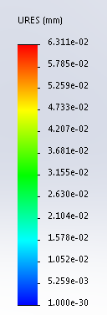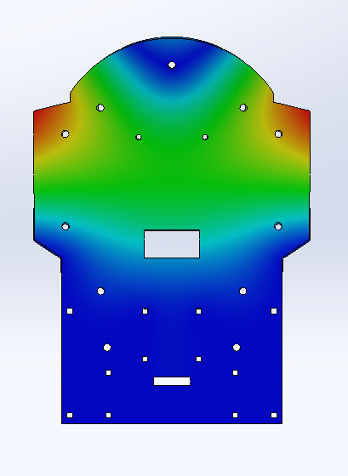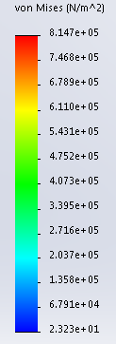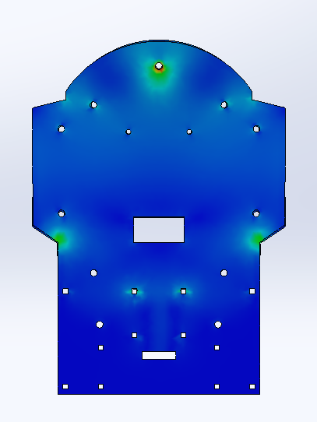To select the material for chassis, compromise must be made between strength, cost and weight. The material that will be used for the chassis will be acetal as it has low density, cost and is easy to manufacture. Low density means buggy will be lighter therefore overall speed and battery life of the buggy will be higher. Low cost is important as the overall budget of project is £40, it must not be exceeded. However, acetal is not the strongest which means it will flex and bend under lower stresses than the other materials, therefore a stress and displacement analysis is required to ensure, if acetal chassis will be able to withstand the load being placed on.

Figure 7.5 stress analysis of bottom plate

Figure 7.4 displacement analysis of bottom plate

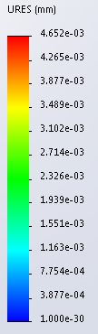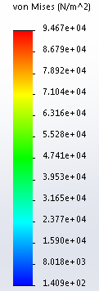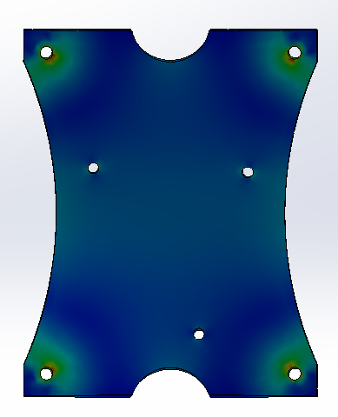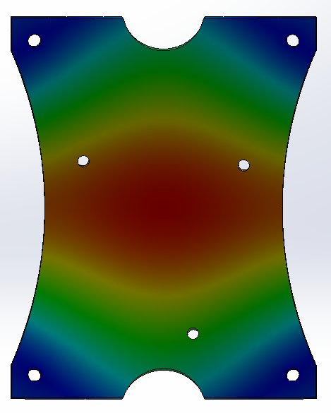

Figure 7.7 stress analysis of top plate

Figure 7.6 displacement analysis of top plate

Deflection is very important as a large deflection will result in a greater bend in the chassis therefore overall driving and handling of the buggy will be affected as the wheels will not work as well and it may also interrupt the performance of the sensors. If the deflection is big enough, chassis can break. To make sure deflection is not too high, load on the chassis should be evenly distributed. As can be seen from the stress analysis, the chassis will be able to withstand the stress being applied to it , and biggest deflection of the chassis is really small( in um) E.g. biggest deflection for top plate is 4.7 um.

Another reasons for acetal being chosen is, it can be cut very easily with a laser cutter, which is what will be used to manufacture the chassis, making the progress straightforward with no hassle. Glass-reinforced laminate and aluminium also have relatively low density and can withstand larger stresses than Acetal however, it is harder to cut these materials into the desired shape due to their properties

* 1. **Design and Layout:**

The overall weight of the buggy (including both plates) is ??, which is close to what was expected. Rear wheel drive (RWD) is preferred to the front wheel drive as having RWD will improve the handling and overall balance of the buggy. Smaller the size of the buggy easier to manoeuvre therefore to make the size of chassis smaller in length the chassis will consist of two plates, upper and lower, which will be connected using spacers, of required length.

Gearbox, caster ball and PCB for the sensor circuit would fit on the underside of the lower plate while motor drive board and battery pack would fit on the top side of the lower plate. Upper plate will be above the drive board and nucleo board will fit on top of it. Holes have been cut into the chassis, so every component will be screwed on the chassis except the battery pack. Velcro will be used to secure the battery pack to the chassis. Slots have been cut for the Velcro strip to thread through. For the gearbox, square holes have been cut on the chassis as the gearbox module has slots cut into it which will fit in the square holes.

Separation between the wheel will influence the buggy. Wider the wheels are the larger the deflection due to increased length of chassis therefore higher chances of it bending. Wider chassis will also increase the weight therefore reducing the speed, and there is also higher risk of buggy touching the sides of the racing track, which will have 28 cm wide pinch points. Taking all this in consideration, buggy will be 19m wide (with tyres on).

Reference

[1] (version 2018). Solidworks: University of Manchester.

[2] (2018-2019). *ESP Technical Handbook*: University of Manchester. 84-85.